# About this Project

To get from where we get the idea for this project imagine a scenario, where we go in a party house with some friends to enjoy our evening but we decided to stay there for a longer period of time and that place has an automatic light system which works on motion detection which is the most common technology nowadays.

But now because it is late and everything has calmed down and we went in small corner of the room to get something but now because there is not motion going on around the motion sensors “the light gets turned off” automatically because the system decided that there is nobody present there...

But what if there was a system that actually counted the total number of people that entered the house and doesn’t turns off the lights until each and every person that came at that frame of time didn’t leave!!

“Where there is darkness. Let there be light.”

Quote by Francis of Assisi

# Components And Basic Working

* Solderless Breadboard.
* Arduino UNO.
* Ultrasonic Sensor (hc-sr04) ×2.
* 16×2 LCD Display.
* 100R Resistor.
* 4.7K Resistor.
* 1K Resistor.
* 1-Channel 5V Relay Module.
* Male to Male Jumper wire.
* Male to Female Jumper wire.
* Bulb Holder.
* LED bulb.

All these components cost approximately around Rs.1,300 and considering the cause it was worth it.

So simply how this whole system functions is initially there is a “Welcome” text displayed on the LCD and there is nobody present in its environment but when it detects a person entering the premises from one of its entry sensor it turns ON the light and starts counting the number of people that entered and there is a exit sensor which counts the number of people leaving the premises.

Now until the number of people exit is equal to the number of people entering is not the same it will not turn OFF the light, and this system will take the proper account of number of people entering and exiting and will also display the number of people which are ‘Currently’ inside...

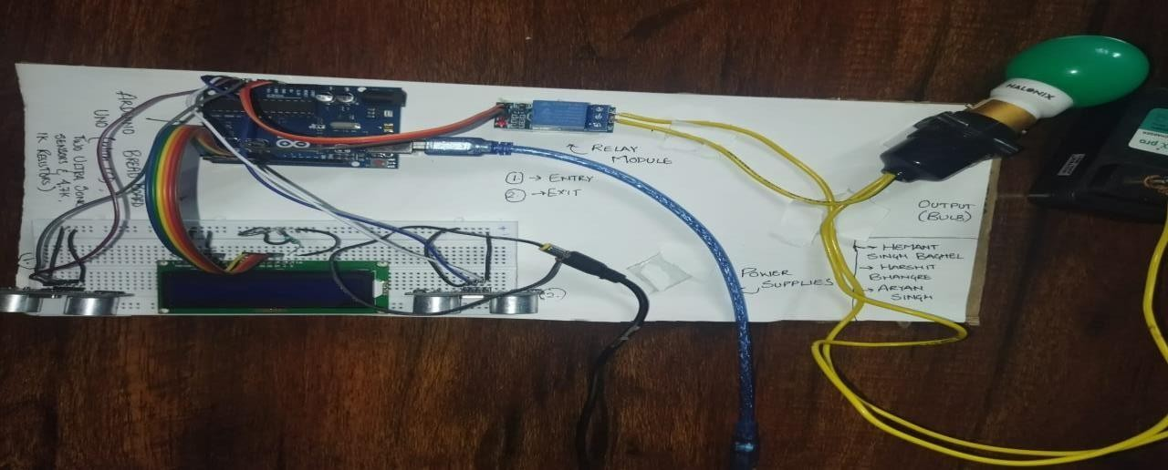

# Circuit Diagram

